1. 
2. Another growth we talk about is logarithmic growth.
3. 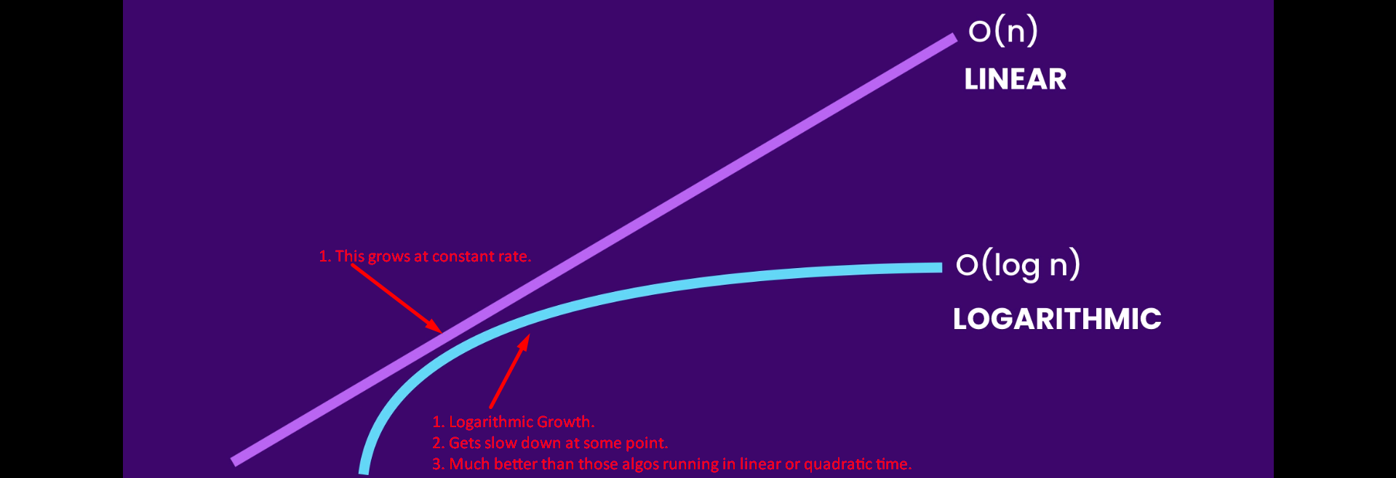
4. Let’s see an example.
5. 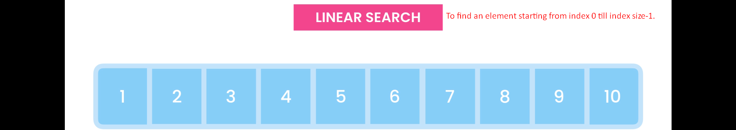So the runtime of this algo increases linearly and so direct proportion to the size of an array.
6. Binary Search  
   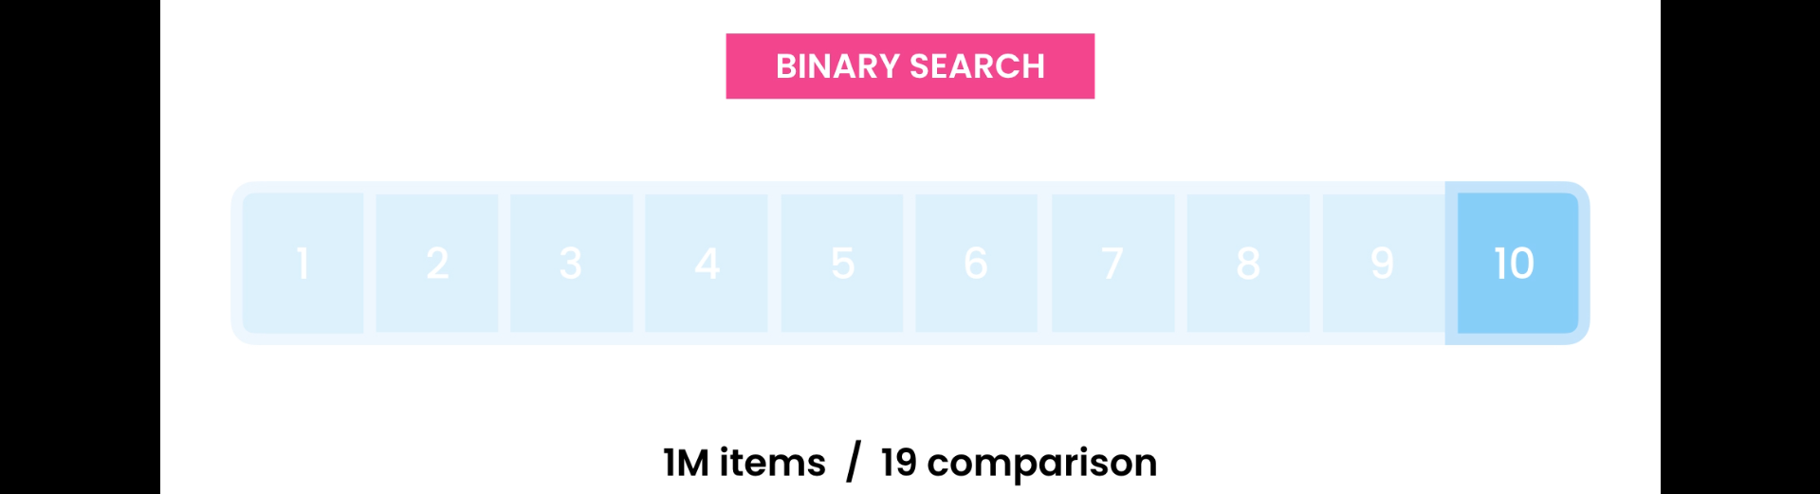
   1. Runs in logarithmic time.
   2. We have logarithmic growth in algo where we reduce our workload in every step.  
      We will see in tree and graph.